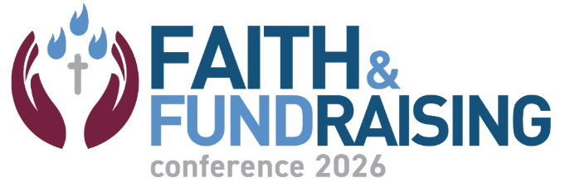

BREAKOUT SPEAKER AGREEMENT
You’re almost ready to speak at Faith & Fundraising: Chicago 2026!

Thank you for offering to share your expertise at Faith & Fundraising: Chicago 2026, and congratulations on being selected as a speaker! We’re very pleased to invite your unique perspective to the diverse and exciting programming for this conference.

This Speaker Agreement outlines important F&F Speaker Terms and Conditions. Please sign and return this agreement.

We will be more than happy to answer any of your questions, so please do not hesitate to reach out to us. Thank you, and welcome to Faith & Fundraising 2026.

Shasta Foy, CAE shasta@acfundraising.org
Executive Director, ACF

Jon Nelson conference@acfundraising.org
Associate Director, ACF

Presented by

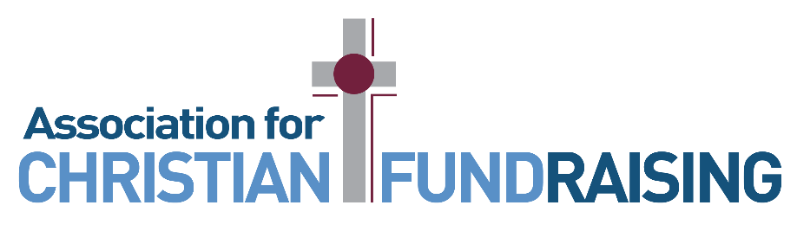

Preparation and Communication

Our aim is to help you be properly prepared so that you can play your part in delivering an excellent event to our participants. The F&F Curriculum Committee selected you based on your experience, expertise, and capacity to inspire our attendees. We look forward to welcoming you to Faith & Fundraising 2026.

Your Attendance/Accommodations/Room Host

We invite you to engage and interact with conference attendees. Your participation includes complementary conference attendance on the day you speak. The networking aspect of the conference is of great value to all nonprofit fundraising professionals and sponsors/exhibitors.
Lodging is at the Chicago Marriott Downtown Magnificent Mile. If you have not yet reserved your room at the Marriott, please do so immediately, and no later than February 2 ($149 per night, plus tax).

https://www.faithandfundraisingconference.org/hotel

We will have volunteer room hosts who will stand ready to introduce you and assist you during your breakout session.

Early Arrival Reception: Sunday, February 22, 2026
If you plan to arrive on Sunday, we invite you to attend our Early Arrival Reception being held from 6:00-9:00 p.m. (location at the Marriott TBA). Please plan to join us and interact with registered attendees, sponsors, and session presenters.

Working Together to Promote Faith & Fundraising

We request that you promote F&F through your own social and professional networks, and to make yourself available for interviews if requested. In agreeing to speak at F&F, you accept that you may be photographed for use in brochures, emails, press features, social media, videos, and on the ACF and F&F websites.

Specific ways to help promote F&F 2026:

- Post about F&F and your session across your social media channels. Please use our official conference hashtag: #FaithFundraising2026 with all of your posts and link to the F&F website https://www.faithandfundraisingconference.org/, while also tagging ACF:

  - https://www.facebook.com/AssociationforChristianFundraising
  - https://www.instagram.com/acf_fundraising/
  - https://www.linkedin.com/company/acfundraising/

- Film a short video about your upcoming session, and be sure to tag us so we can share it.

F&F Speaker Support Program

All F&F speakers will be asked to attend a virtual speaker support session, which will include training, insights, and mentorship in advance of F&F. We will follow up with further details in the coming weeks and hope that this program ensures the highest quality of presentation and audience engagement for the participants at the conference. We look forward to working together with you to make your session(s) the best they can be. We want all attendees to have a positive F&F experience!

Commercialism Reminder: Content Expectations for Selected Speakers

Please remember that, when submitting your session proposal, you agreed to the following terms, and are again being asked to acknowledge them:

Please note that ACF maintains a strong expectation of non-commercial content. Presentations should be educational in nature and focused on sharing strategies, insights, or practical takeaways — not promoting specific products, services, or companies. Company logos may be used only to indicate presenter affiliation.

The Curriculum Committee reviewed all proposals with this expectation in mind.

Your Next Steps

There are four things for you to do right now:

- Review this Speaker Agreement carefully to make sure that you understand all the terms and conditions of being a keynote speaker at F&F 2026.

- Reply by email to conference@acfundraising.org and return a signed copy of the agreement, thus confirming your speaking place.

- Be on the lookout for future emails from us. These important emails will contain deadlines and other information about making your F&F experience as successful and memorable as possible.

- Start sharing more information about #FaithFundraising2026 with your networks and on social media! Let your friends and colleagues know that you will be a keynote speaker at F&F 2026, and share the link to the event: https://www.faithandfundraisingconference.org/

Shasta Foy, CAE
Executive Director, ACF

Signature_________ _______Date: _October 17, 2025_______________

Your Name (Print): ___________________________

Signature: __________________________________ Date: _________________________

