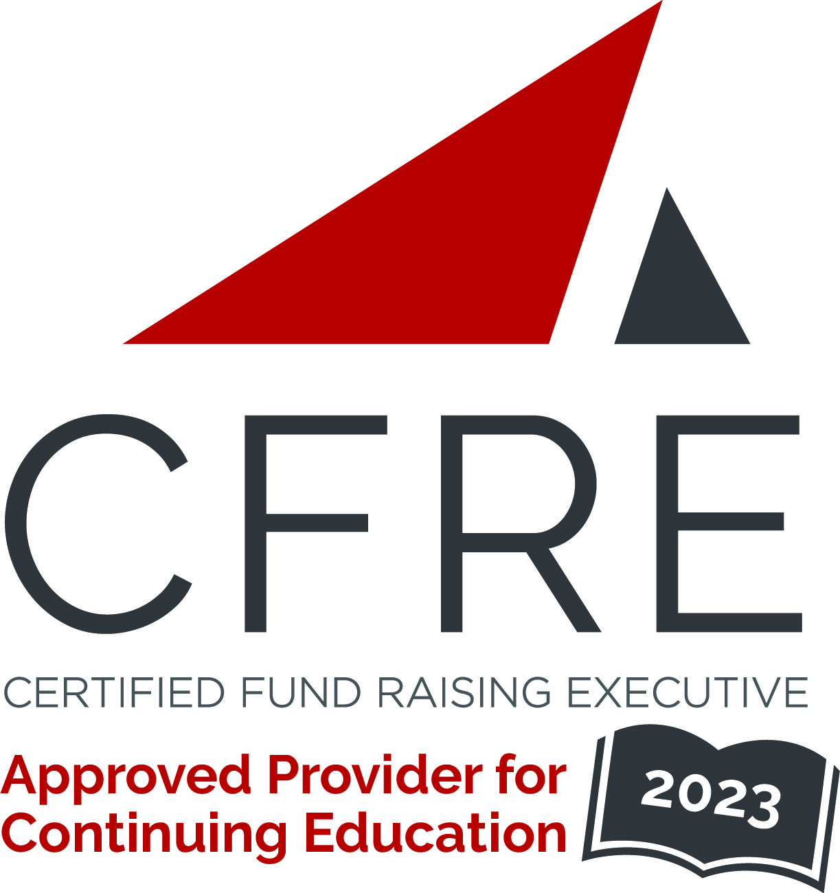  CFRE International has developed this form as a way for you to quickly track (and keep in your files!) the continuing education sessions you have attended. Simply check the boxes next to the sessions you attended. At the end of the conference, add up the total number of hours. Keep this sheet and you will be ready to complete your application form. All of the session slots listed are eligible for continuing education points on your CFRE application for initial certification and/or recertification. Sessions not listed here are not eligible for points. |  | CONTINUING EDUCATION POINTS TRACKER

Activity Organizer: - ALDE
Title of Activity: - Faith & Fundraising: Myrtle Beach 2023
Names of Presenter(s): - Various
Dates and Location: - February 26 – March 1, 2023

Date: 26 February, 2023
Session 1: 2:30pm – 4:30pm (2 pts)
- Master Class: Telling Your Story for Impact
- Master Class: Advanced Facilitation Training

Date: 27 February, 2023
Session 2: 6:00pm – 7:30pm (1.5 pts)
- Keynote: Faith and Philanthropy: Work as Worship

Date: 27 February, 2023
Session 3: 10:00am – 11:15am (1.25 pts)
- Fundraising / Stewardship 101
- Major Gift Success Begins with Donor Acquisition
- Is Your Organization a Culture Magnet
- The Current State of Donor Retention
- Mercy Before Money
- How to Make Your Donors Feel Appreciated
- Innovation Room

Date: 27 February, 2023
Session 4: 12:00pm – 12:45pm (1 pt)
- Keynote: Planned Giving Comedy Hour

Date: 27 February, 2023
Session 5: 1:30pm – 2:45pm (1.25 pts)
- Developing Your Board or Council to Effectively Lead and Be Prepared
- X Marks the Spot: Building a Roadmap to Effective Grant Writing
- Donor Diversity
- Putting Your Developmental Tacklebox Together
- Pairing Planned Giving and Endowment
- The Current State of Donor Retention
Elements of a Successful Campaign
- Innovation Room

Date: 27 February, 2023
Session 6: 3:15pm – 4:30pm (1.25 pts)
- Building Your Case Support
- Building a Fundraising Culture
- Creating Brand First Donor Experiences
- Think Tank Tactics, Strategy, Execution
- Amplify Your Fundraising by Putting Personalized Donor Communications to Work
- Planned Giving With a Shoe String Staff and Shoe String Budget
- Innovation Room

Date: 28 February, 2023
Session 7: 8:30am – 9:30am (1 pt)
- Keynote: Finding Purpose in the Pain

Date: 28 February, 2023
Session 8: 9:45am – 11:00am (1.25 pts)
- Telling Your Story for Impact – Master Class Follow-Up
- Reduce Dependency on Year-End and Episodic Giving
- How to Listen for Planned Gifts
- Board Engagement with Fundraising
- Leading From the Second Chair
- Blog with a Purpose – Turn Stories Into Donations
- Innovation Room

Date: 28 February, 2023
Session 9: 12:00pm – 1:00pm (1 pt)
- Keynote: What If There is a Recession, but No One Shows Up?

Date: 28 February, 2023
Session 10: 2:30pm – 3:45pm (1.25 pts)
- How to Ask
- What do Digital Fundraising and “Moneyball” Have in Common
- Neuromarketing for Nonprofits: Planned Giving
- The Generosity Story
- Earning Our Profession’s Credential: The A – Z of Becoming a CFRE
- Subscription Philanthropy: Breakthroughs in Sustainable Giving
- Innovation Room

Date: 28 February, 2023
Session 11: 4:15pm – 5:30pm (1.25 pts)
- Strategic Planning and its Intersection with Fundraising
- The Floor is Yours!
- Neuromarketing for Nonprofits: Planned Giving
- Finding Serenity in Uncertain Financial Times
- Must Have Pillars of a Thriving Major Gifts Program
- Rekindled to Respond – From Crisis to Unprecedented Growth
- God’s Word – Where Faith and Fundraising Meet
- Innovation Room

Date: 1 March, 2023
Session 12: 9:00am – 11:00am (2 pts)
- Closing Session: Conclusions from the Big 3 Challenges and Keynote Panel

Total number of points attained: __________

